Edge Detection

function EdgeDetectionGUI
clc;
close all;

cam=[];
running=false;
processedImage=[];

%% ---------------- GUI ----------------
fig=uifigure(...
'Name','IMAGE EDGE DETECTION ',...
'Position',[100 100 1200 650]);

%% Axes
ax1=uiaxes(fig,'Position',[50 350 300 230]);
title(ax1,'Original');

ax2=uiaxes(fig,'Position',[450 350 300 230]);
title(ax2,'Canny');

ax3=uiaxes(fig,'Position',[850 350 300 230]);
title(ax3,'Sobel');

ax4=uiaxes(fig,'Position',[250 70 300 230]);
title(ax4,'Prewitt');

ax5=uiaxes(fig,'Position',[650 70 300 230]);
title(ax5,'Enhanced');

%% Buttons
uibutton(fig,...
'Text','Start Webcam',...
'Position',[80 610 150 30],...
'ButtonPushedFcn',@startWebcam);

uibutton(fig,...
'Text','Upload From OneDrive',...
'Position',[280 610 180 30],...
'ButtonPushedFcn',@uploadImage);

uibutton(fig,...
'Text','Save Result',...
'Position',[500 610 150 30],...
'ButtonPushedFcn',@saveResult);

uibutton(fig,...
'Text','Stop Webcam',...
'Position',[700 610 150 30],...
'ButtonPushedFcn',@stopWebcam);

uibutton(fig,...
'Text','Exit',...
'Position',[900 610 150 30],...
'ButtonPushedFcn',@exitApp);

%%%%%%%%%%%%%%%%%%%%%%%%%%%%%%%%%%%%%%%%%%
%% Start Webcam
function startWebcam(~,~)

try
cams=webcamlist;

if isempty(cams)
uialert(fig,...
'No webcam detected.',...
'Webcam Error');
return
end

if isempty(cam)
cam=webcam(1);
pause(2);
end

running=true;

while running

try
frame=snapshot(cam);
catch
pause(0.1);
continue
end

processImage(frame);

drawnow
pause(0.05)

end

catch ME

uialert(fig,...
ME.message,...
'Webcam Error');

end

end

%%%%%%%%%%%%%%%%%%%%%%%%%%%%%%%%%%%%%%%%%%
%% Upload Image From OneDrive
function uploadImage(~,~)

try

% Windows or Linux OneDrive path
if ispc
onedriveFolder = fullfile(...
getenv('USERPROFILE'),...
'OneDrive');
else
onedriveFolder = fullfile(...
getenv('HOME'),...
'OneDrive');
end

% Fallback if OneDrive missing
if ~isfolder(onedriveFolder)
onedriveFolder=getenv('HOME');
end

[file,path]=uigetfile(...
{'*.jpg;*.jpeg;*.png;*.bmp;*.tif',...
'Image Files'},...
'Select Image From OneDrive',...
onedriveFolder);

if isequal(file,0)
return
end

img=imread(fullfile(path,file));

processImage(img);

uialert(fig,...
'Image uploaded successfully!',...
'Success');

catch ME

uialert(fig,...
ME.message,...
'Upload Error');

end

end

%%%%%%%%%%%%%%%%%%%%%%%%%%%%%%%%%%%%%%%%%%
%% Image Processing
function processImage(frame)

if size(frame,3)==3
gray=rgb2gray(frame);
else
gray=frame;
end

% Noise Reduction
smooth=imgaussfilt(gray,2);

% Edge Detection
canny=edge(smooth,'canny',[0.1 0.3]);
sobel=edge(smooth,'sobel');
prewitt=edge(smooth,'prewitt');

% Morphological Enhancement
se=strel('line',3,0);
enhanced=imdilate(canny,se);

processedImage=enhanced;

%% Display Results
imshow(frame,'Parent',ax1)
imshow(canny,'Parent',ax2)
imshow(sobel,'Parent',ax3)
imshow(prewitt,'Parent',ax4)
imshow(enhanced,'Parent',ax5)

end

%%%%%%%%%%%%%%%%%%%%%%%%%%%%%%%%%%%%%%%%%%
%% Save Result
function saveResult(~,~)

if isempty(processedImage)

uialert(fig,...
'No processed image available.',...
'Error');
return

end

[file,path]=uiputfile(...
'EdgeResult.png');

if isequal(file,0)
return
end

imwrite(processedImage,...
fullfile(path,file));

uialert(fig,...
'Image Saved Successfully!',...
'Success');

end

%%%%%%%%%%%%%%%%%%%%%%%%%%%%%%%%%%%%%%%%%%
%% Stop Webcam
function stopWebcam(~,~)

running=false;

if ~isempty(cam)
clear cam
cam=[];
end

end

%%%%%%%%%%%%%%%%%%%%%%%%%%%%%%%%%%%%%%%%%%
%% Exit App
function exitApp(~,~)

running=false;

if ~isempty(cam)
clear cam
cam=[];
end

delete(fig)

end

end
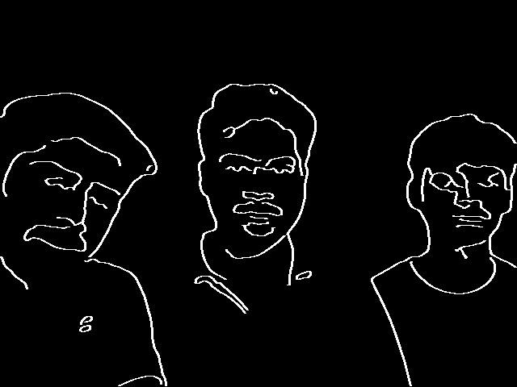

Real-Life Applications of Your MATLAB Edge Detection GUI

1) Security & Surveillance Systems
Intruder detection in restricted areas
Detect movement near doors/windows
Boundary detection in CCTV footage

2) Autonomous Vehicles / Driver Assistance
Road lane markings
Traffic signs
Vehicle boundaries
Pedestrians

